In this issue: Chevy Chase Small Area Plan Community Open House; Historic District Zoom Webinar; Episcopal Center for Children and Maret Sports Field; Ward 3 ANC Redistricting Task Force; March 23. 7-8 pm: Maintaining Brain Health: Do's and Don'ts; DC Primary Candidate Forums; April 23. 7 pm Creating a Pollinator Garden -- Virtual Webinar; Chevy Chase Seeks Master Gardeners for Tree Box Planning; ANC Grant to CCCA; Webinar with Mary Cheh; Ward 3 Councilman Candidate Forum; Call Boxes; Windows on Wisconsin (WOW!); Report on Crime in our Neighborhood; Opinion on Historic District Designation
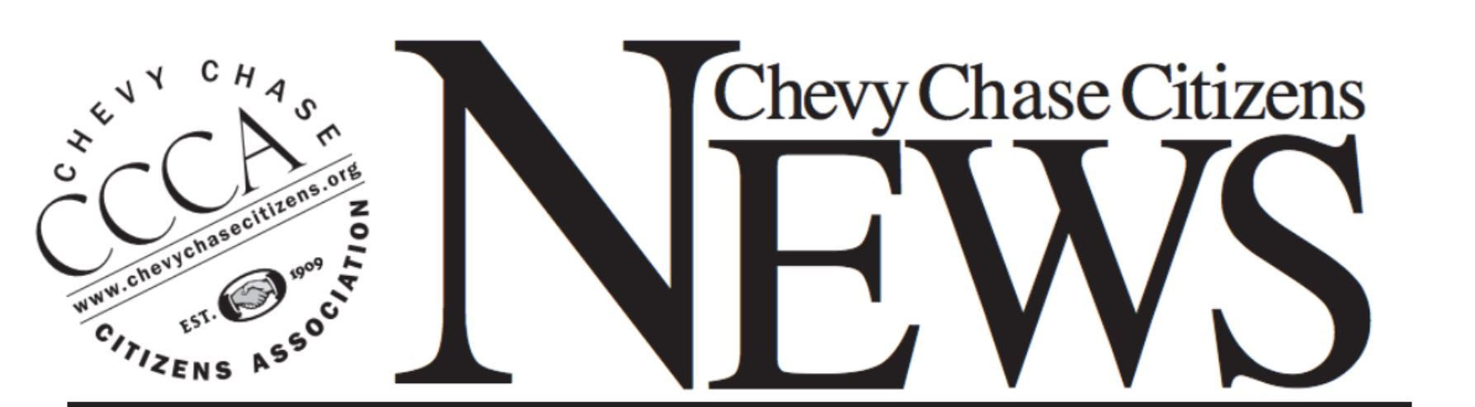

February 2022

Schedules and Events

Chevy Chase Small Area Plan Community Open House
February 23. From 3:00 - 7:00pm (Wednesday). Join the DC Office of Planning for an SAP Community Open House at the Chevy Chase Library (upstairs meeting room).
According to the Office of Planning, the Open House will allow community members to:
- view presentation boards about the Small Area Planning process.
- find out about what has been heard so far.
- view graphics of potential growth along the Connecticut Avenue corridor.
- learn about draft design principles and guidelines.
One vision of upper Connecticut Avenue for the future

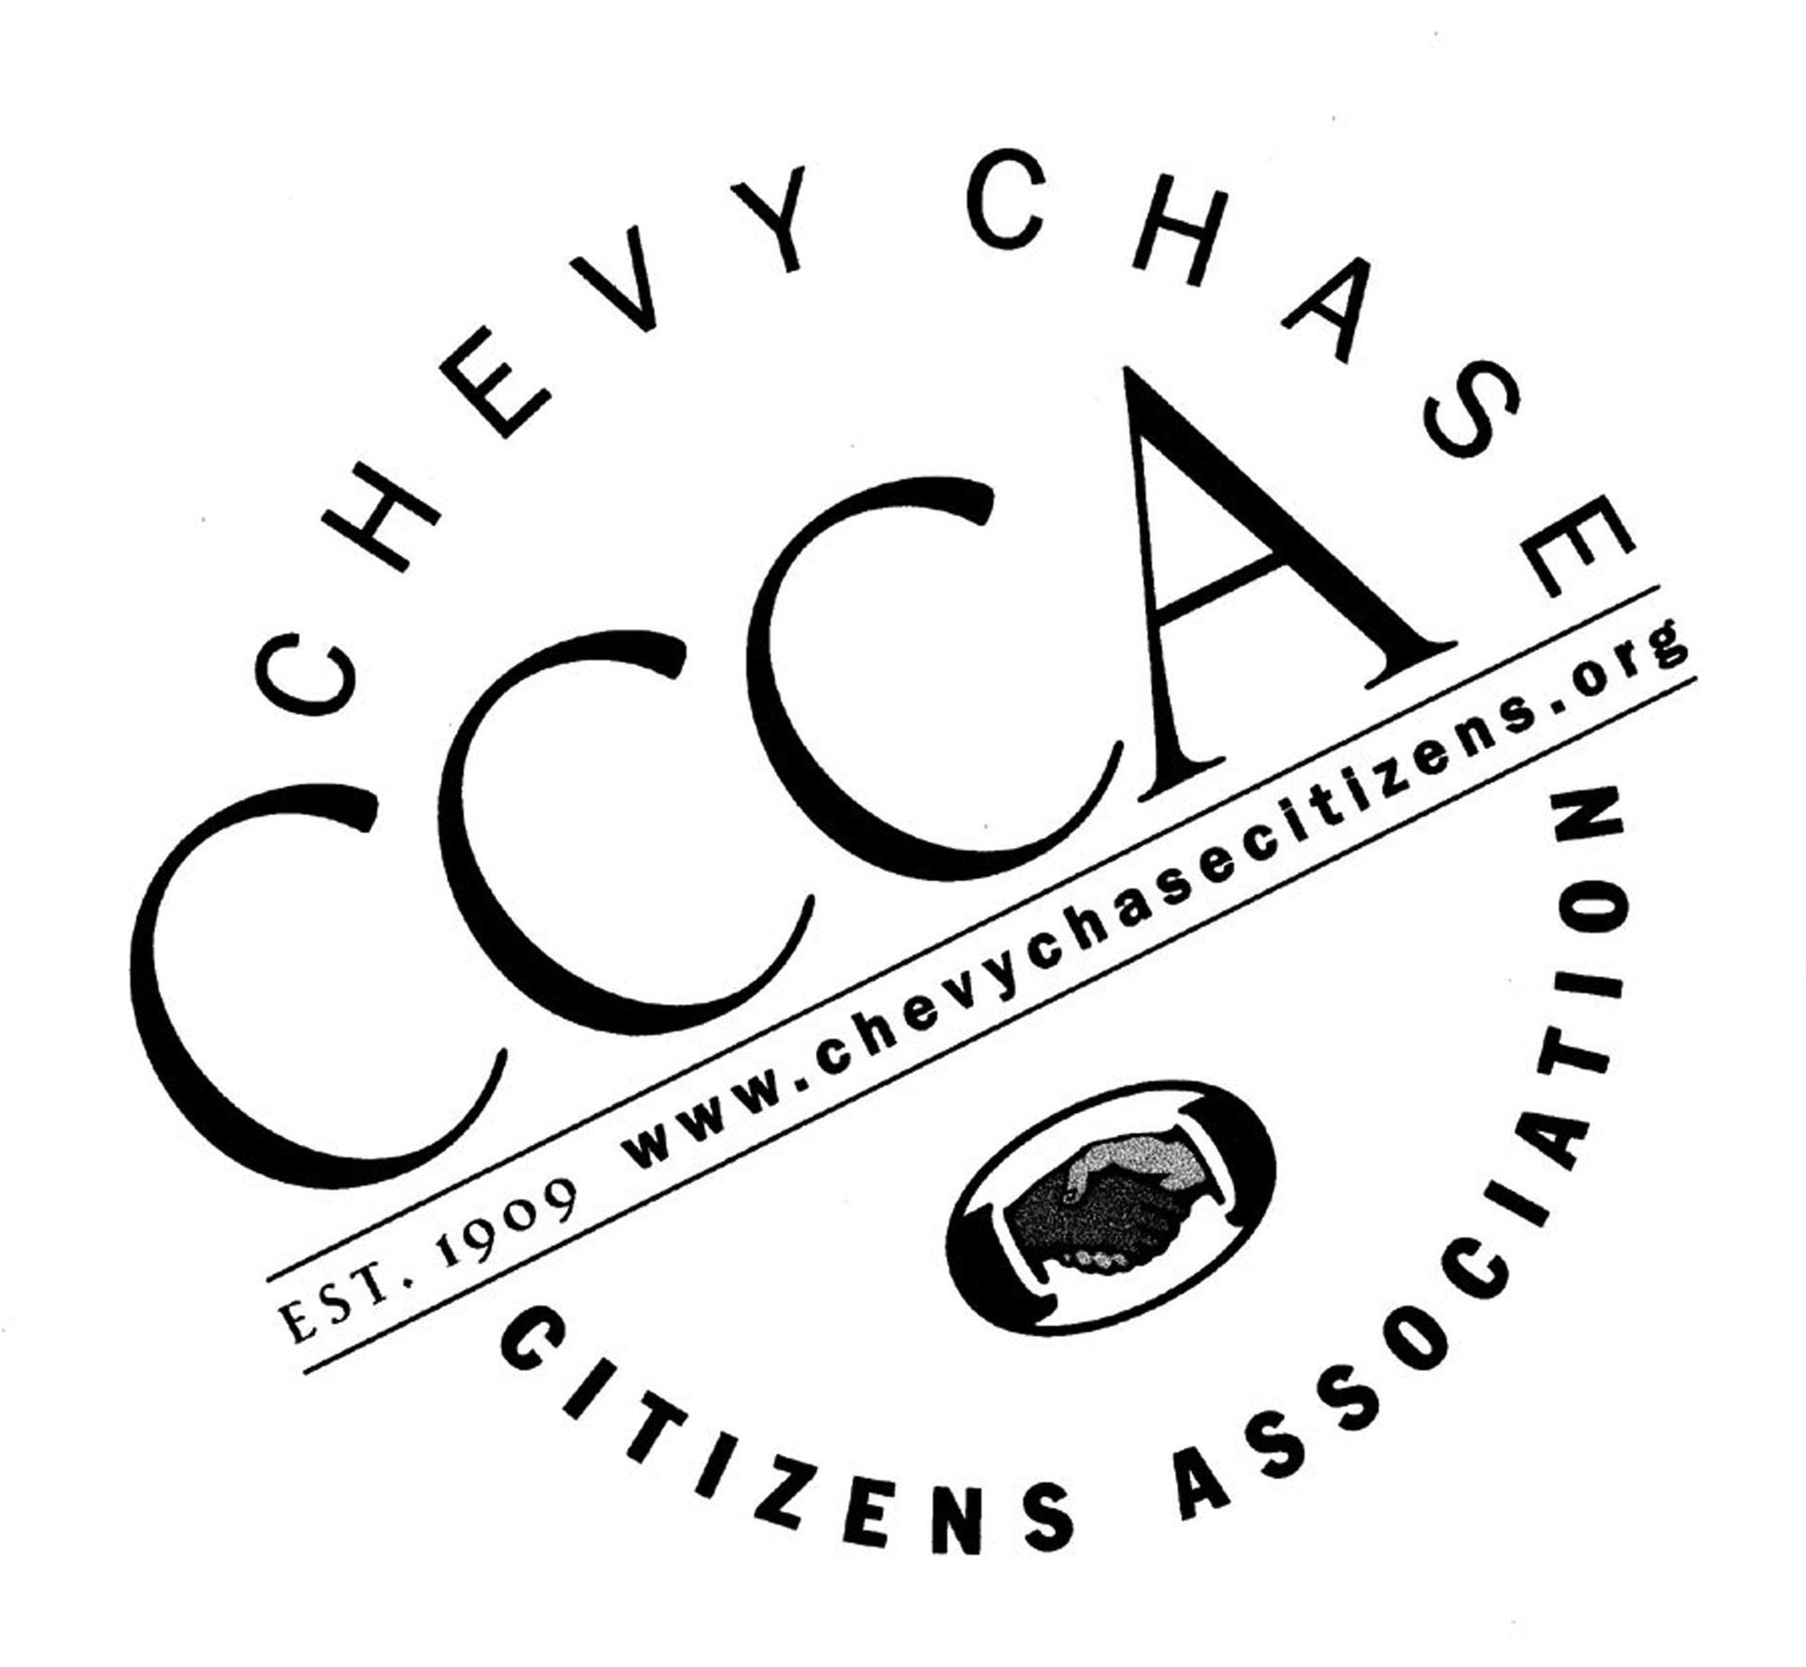

If you haven’t already, please renew your membership by visiting www.chevychasecitizens.org and clicking on “renew” at the top. Dues are $20 per year for two members from one household.

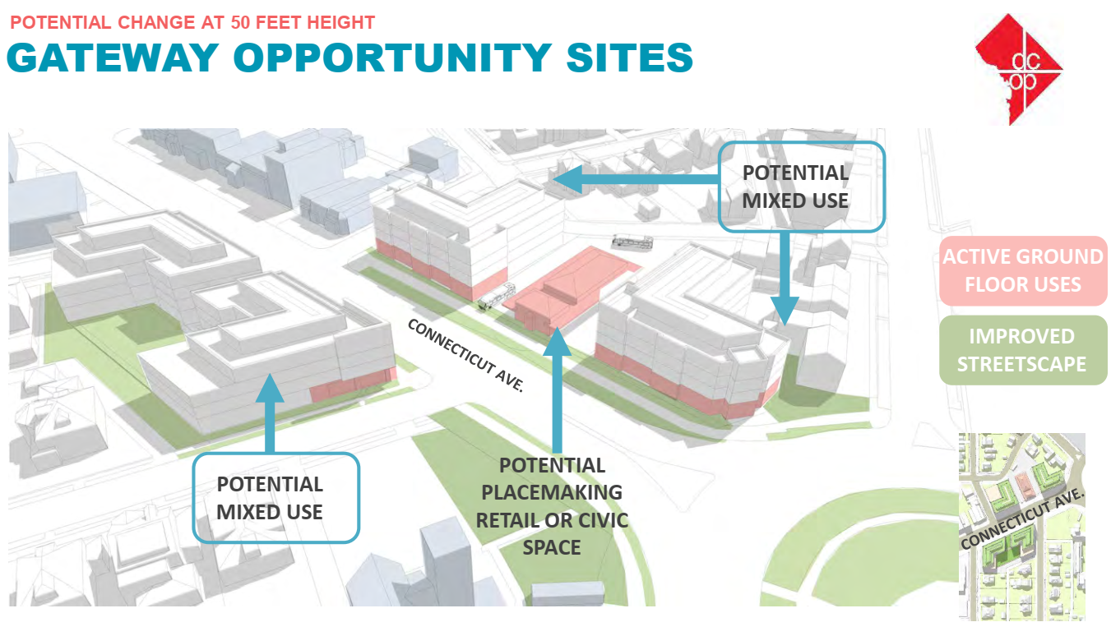
Credit: Office of Planning
The activity is intended to enable in-person conversations between community members about the future of the Chevy Chase neighborhood. OP staff will be available to describe the presentation boards and answer any questions.
One vision of upper Connecticut Avenue for the future
The February 23 Open House is a drop-in activity and there is no need to register. To learn more about the Chevy Chase Small Area Plan and review information from past meetings and events go to publicinput.com/chevychase. CCCA encourages all residents to participate and make your views known.

Historic District Zoom Webinar
March 3. 7 PM. CCCA, ANC 3/4G, and HCCDC are cosponsoring a panel discussion exploring the issue of an Historic District designation for Chevy Chase. The panel will be comprised of experts in the field of Historic Districts featuring two professionals from the Office of Historic Preservation within the DC Office of Planning. One of the main topics is how historic designation can support and enhance the Small Area Plan that is now in the final stages of fact-finding and heading toward completion. (* see the opinion piece on this topic below.)

Episcopal Center for Children and Maret Sports Field
March 9, beginning at 9:30 AM, the Board of Zoning Adjustment will hear Maret School’s request for zoning relief to construct sports fields on the ECC property. Maret submitted its application to the DC Board of Zoning Adjustment (BZA) on November 1, 2021 and refiled a corrected version of its application a day later. Advance registration will be available the day before the hearing.
The Episcopal Center for Children (ECC) and Maret School have entered a long-term lease that will allow Maret to use the grounds behind the ECC’s buildings, as well as the smallest of its four buildings, to create a multi-sport field and baseball diamond with an adjacent parking lot and fieldhouse facilities. Proposed New Field | Maret School, DC
For those interested in being heard, contact the Public Space Committee or the Board of Zoning Adjustment. For more information about the issues and concerns surrounding the field, you may contact Friends of the Field, an alliance of Chevy Chase neighbors, families, and concerned citizens, that care about safety, environmental stewardship, and quality neighborhood life. friendsofthefield20015@gmail.com
One Vision of the Fields
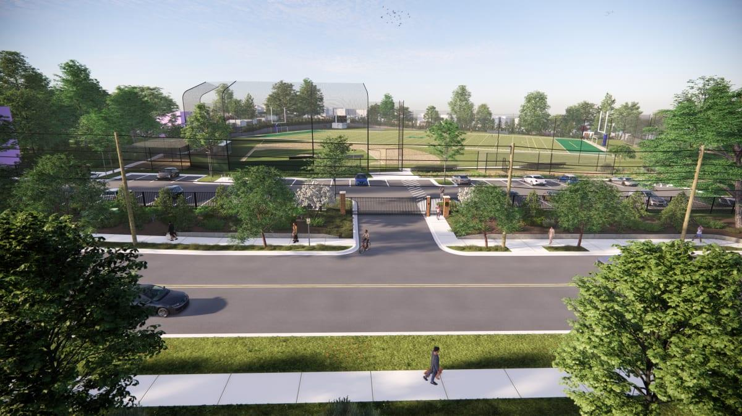
Picture Credit: Maret

Ward 3 ANC Redistricting Task Force
Jerry Malitz, former ANC Commissioner has been appointed by Councilmember Mary Cheh to spearhead the Task Force to draw new ANC boundaries throughout Ward 3 (and a small part of Ward 4).
The Task force will draw new boundaries for each ANC single member district (SMD) in the ward, and decide which SMDs are assigned to which ANC. Every SMD, which elects one ANC commissioner, must have a population of between 1,900 and 2,100 residents, using the 2020 Census data. There is no minimum or maximum number of SMDs in an ANC, but most ANCs currently have between five and nine SMDs.
An ANC may cross a ward boundary, but according to District law, each ANC must, "to the greatest extent possible," be located within one ward. The ANC boundary recommendations prepared by the task forces are not binding on the Council.
Meeting Schedule - Meetings begin at 7:30pm on the following dates and are scheduled for 1 hour. All meetings are open to the public via Zoom. Recordings are made available following the meetings.
- Tuesday, February 22
- Tuesday, March 1
- Tuesday, March 8
- Tuesday, March 15
- Tuesday, March 22
- Tuesday, March 29

March 23. 7-8 pm: Maintaining Brain Health: Do's and Don'ts
Northwest Neighbors Village and CCCA will be presenting its annual March virtual discussion on the healthy brain and how to keep it that way.
Jesse G. Brand, Ph.D., ABPP, Board Certified in Clinical Neuropsychology will be our presenter. He will explore how thinking abilities change as we age, and what can we do about it? Gain insight into research-supported lifestyle changes that can build resilience against dementia. Learn more about which brain health products are falsely advertised and what the evidence really suggests about optimizing memory.
Dr. Brand is a board-certified clinical neuropsychologist, evaluating adults with a range of psychiatric, neurological, and medical disorders. His primary specialties include differential diagnosis of dementia, traumatic brain injury, mild autism, and adult ADHD.
Dr. Brand was born and raised in New York City. After completing his Ph.D. in Clinical Psychology at Fordham University – including residency at North Shore-Long Island Jewish Medical Center – he was a post-doctoral fellow in Clinical Neuropsychology at the University of Virginia. He is licensed in Maryland, Virginia, Washington D.C, and New York.

DC Primary Candidate Forums
CCCA will be co-sponsoring primary candidate forums according to the following preliminary schedule. Forums will be virtual. Once all candidates have confirmed their availability, firm dates and times will be announced. More information will be forthcoming:
- Tuesday, April 26 at 7pm: DC Mayor
- Wednesday, April 27 at 7pm: DC Council Chair
- Thursday, May 12 at 7pm: DC Council At-Large
- Monday, May 16 at 7pm: DC Attorney General

April 21. 7 PM Creating a Pollinator Garden – Virtual Webinar
CCCA is presenting Master Gardener Kathy Sykes who will be offering local residents easy steps to create a pollinator garden or corridor in our community. Her presentation covers the step-by-step process while also discussing the benefits of pollinators to the environment and humans, the importance of keystone plants and trees, how to plant for continuous flowers, and how to develop partnerships in your local community to garner support.

New Initiatives

Chevy Chase Seeks Master Gardeners for Tree Box Planning
Friends of Chevy Chase Circle, Chevy Chase Citizens Association, and the Chevy Chase Main Street seek the expertise of DC’s Master Gardeners to help lead planning, management, and implementation of plantings in tree boxes along Connecticut Avenue. For years, the garden club of the CCCA led by Barbara Baldwin planted and maintained the tree boxes with funding from the CCCA. We even paid for a traveling water wagon so they could be watered as part of the maintenance. Recently tree boxes have not been managed by a single group or business. The three organizations seek to share resources and work alongside a Master Gardner to replant them.
The group seeks to meet with interested Master Gardeners to discuss what kinds of plantings would work best for the area, as well as help with community days to tend to the boxes. The three groups would like to connect their existing volunteer networks with the effort for workdays in the spring.
If you are interested, please reach out to Alex Krefetz at ccms@districtbridges.org or President@chevychasecitizens.org.

ANC Grant to CCCA
CCCA was awarded a $2000 grant by the Chevy Chase ANC 3/4G to migrate our website from an old platform to a new one. In the process, we will improve the appearance and functionality of the website. The effort should take about 6 weeks (fingers crossed). Once the work is done, we will announce the rollout to the entire community. Thank you to the ANC for its generous grant.

Webinar with Mary Cheh
CCCA will be holding a farewell discussion with Ward 3 Councilmember Mary Cheh in April, date to be determined. CCCA President Robert Gordon will discuss with CM Cheh her key successes in office and what she hopes to accomplish during the balance of her term.

Ward 3 Councilman Candidate Forum
CCCA is working with other Ward 3 communities to hold a candidates' forum and the date will be provided in our March Newsletter with more details.

Call Boxes
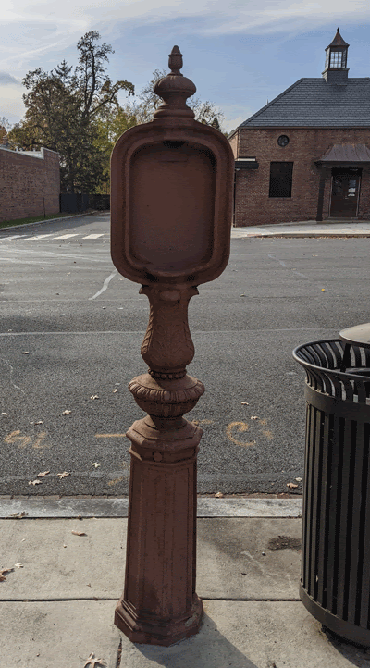
CCCA, HCCDC and Ch/Art are working together to restore what many consider to be an eyesore into something we could be proud of and point to during history walks, art walks, visiting businesses, or just strolling in the neighborhood. We have nine call boxes in the immediate vicinity of the Connecticut Avenue business district.
Our plan is to review the structural integrity of the call boxes and restore the steel to good condition. We will then add art to them. Each box will be privately funded, and a plaque of the funders will be attached to the finished box. For information how to contribute, please write to president@chevychasecitizens.org.

Windows on Wisconsin (WOW!): Ongoing

Ch/Art, a Chevy Chase nonprofit community arts organization presents WOW! a dynamic display of the creativity of neighborhood artists running for a full year through 2022. The curated shows will present the work of local artists, seven at a time, each for a three‐month period, in the shop windows at 5510 Wisconsin Avenue in Chevy Chase, MD. New shows will be presented in the spring, summer and fall of 2022.
For additional information, please contact Kathleen Zeifang at khzeifang@gmail.com or 703‐447‐8758. WOW!, 5510 Wisconsin Avenue, Chevy Chase, Maryland 20815

Report on Crime in our Neighborhood -- Kristine Desmarais
Like many major cities, Washington DC is experiencing an increase in violent crime, including homicides and carjackings. In 2021, our city reached 226 homicides, which is a record number over the last ten years. Not since 2003 when we experienced 262 homicides have we seen a number this high. There are several suggested reasons for the increase. The most notable reason is the effects of the pandemic, which eliminated jobs, disrupted social services, and impacted public transportation, schools, and the judicial system. Tensions are high and violence is erupting even over trivial matters. However, other factors contribute to this crime surge that are not pandemic related.
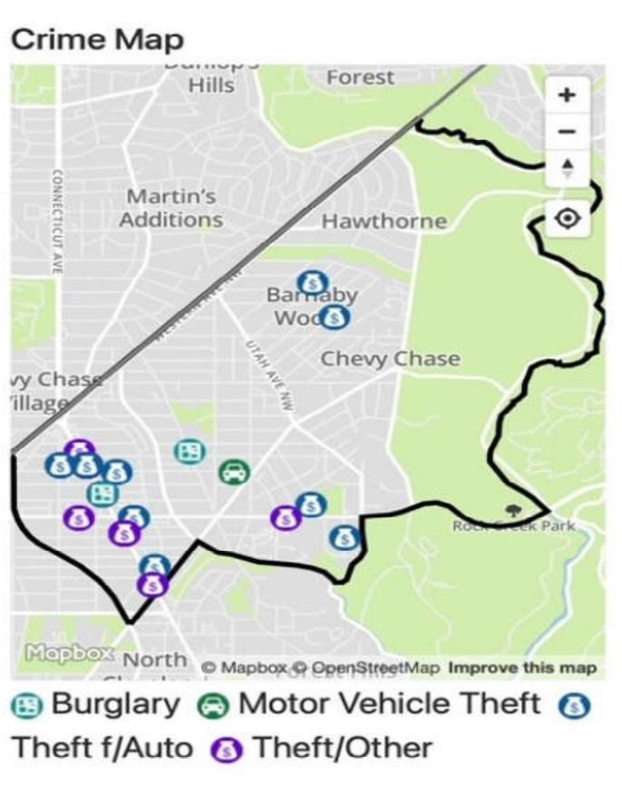
Washington DC has the fewest police officers on staff since 1999 when the force was at 3460 and our total population was smaller. The MPD currently employs 3,514 officers serving 690,000 DC citizens. The Police Department reports that in 2021 there were 200 fewer officers than in 2020 and this does not include over 500 officers who tested positive for Covid and were out sick. Other officers who came in contact with a Covid-positive officer also had to quarantine. Because of a funding cut and hiring freeze in 2020, these officers could not be replaced. See Post article. Funding was included in the 2022 budget to permit hiring at MPD; however, staffing will not reach previous levels.
Chevy Chase DC, which is within Police Service Area 201 (PSA 201), has the lowest crime rate in the city but our neighbors at PSA 202 (Friendship Heights) and PSA 203 (Forest Hills) are seeing more dramatic increases in crime.
Commander Duncan Bedlion of the Metropolitan Police Department 2nd District has referred three buildings within PSA 203 (3003 Van Ness Street, the Saratoga at 4601 Connecticut Avenue, and the Chesapeake at 4607 Connecticut), to the Office of the Attorney General as “nuisance properties” due to their high volume of police service calls. While he considers crime to be relatively stable in the Second District, he mentioned an increase in Assaults with Dangerous Weapons in PSA 203 in 2021. There were 16 in 2021 compared to 3 in 2020. (good)
Here is break down of crime in PSA 201 from the MPD website, compared to the same period last year. While crime is down overall, there is an increase in burglary and theft.

Crime Stats For PSA 201
If you would like to become more involved with the CCCA’s efforts to decrease crime in the area, please contact Samantha Nolan, Director of Neighborhood Watch for the Chevy Chase community and Citywide Crime Prevention Trainer at nolantutor@gmail.com. She will be holding a training session within the next few weeks to teach neighbors how to decrease their likelihood of becoming a crime victim.
Here are a few tips from CCCA’s Samantha Nolan:
- remember to remove all valuable items (even loose change) from your vehicle,
- lock the doors to your vehicles and your home even while you are home, and
- NEVER leave your car motor running while you are not in the car.
- If you are traveling, please stop your newspapers, ask a neighbor to shovel your sidewalk if it snows, and have a neighbor take in your mail daily.
- Putting lights inside and out on timers makes your home look occupied which could prevent a burglary.

Opinion on Historic District Designation
Creating a Chevy Chase DC Historic District supports affordable housing and greater inclusivity and gives residents and our Advisory Neighborhood Commission (ANC) a powerful voice with which to manage change that is respectful of our neighborhood’s heritage, scale and architectural distinction.
While the Chevy Chase Small Area Plan can identify goals and “strategic priorities” and outline “recommendations for growth and development”, it cannot be relied upon to protect the charm, historic architecture and affordability of our neighborhood, or require compatibility of construction, especially between commercial and lower density residential areas. For that, we need a Chevy Chase DC Historic District.
A historic district ensures our neighborhood's interests are protected and provides a level of design review through the Historic Preservation Office and the Historic Preservation Review Board that can enhance any project and make it more compatible with its surroundings.
Creating a historic district will not stop development or freeze our neighborhood in time. New development regularly occurs in the 37 neighborhood historic districts across the city and new development will happen in Chevy Chase DC with or without a historic district.
With a historic district, residents and the Chevy Chase ANC will have a say about all new construction projects within the designated area.
Without a historic district, residents and the ANC will not be permitted any oversight over Matter-of-Right building projects and will be limited to reviewing only large-scale Planned Unit Developments (PUDs) which are heard before the DC Zoning Commission and rarely denied.
A Chevy Chase DC Historic District is the most powerful, legal tool at our disposal to protect our treasured "small town in a big city" and ensure all new development projects go through a design review process that gives residents and the Chevy Chase ANC the opportunity to help shape future changes to our neighborhood. Creating a historic district is the progressive, environmentally sustainable way to manage change, which is a constant in our lives.
Mary Rowse
merowse@aol.com

This message was sent to you by the Chevy Chase Citizens Association
If you no longer wish to receive these emails, you can unsubscribe at any time

